Setting/Location

- The natural setting of the novel (Hanging Rock – a massive volcanic outcropping at Mount Macedon Central Victoria) represents the Australian bush



- Mrs. Appleyard’s College is a college for young ladies – a world of money, manners and gentility. It represents a world separated from nature. It represents the values of the establishment, inherited from the “mother country” (England).
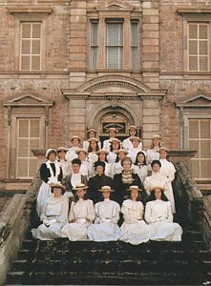
- These two settings symbolize states of mind and body – freedom versus restrain, endangerment versus security, the natural environment versus the cultural world.

Time:
- St Valentine’s Day 1900: This day originates from an ancient Roman (pagan) festival, Lupercalia, to celebrate sexuality and love. The Christian adoption of this celebration suppresses the sexuality and has a stronger focus on love.

